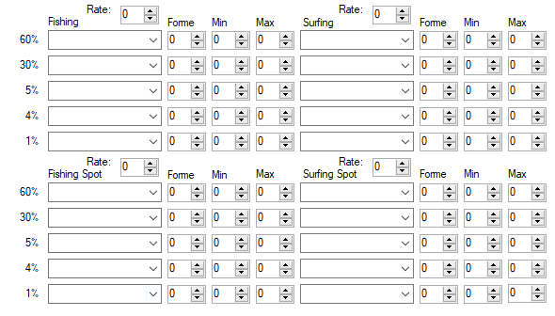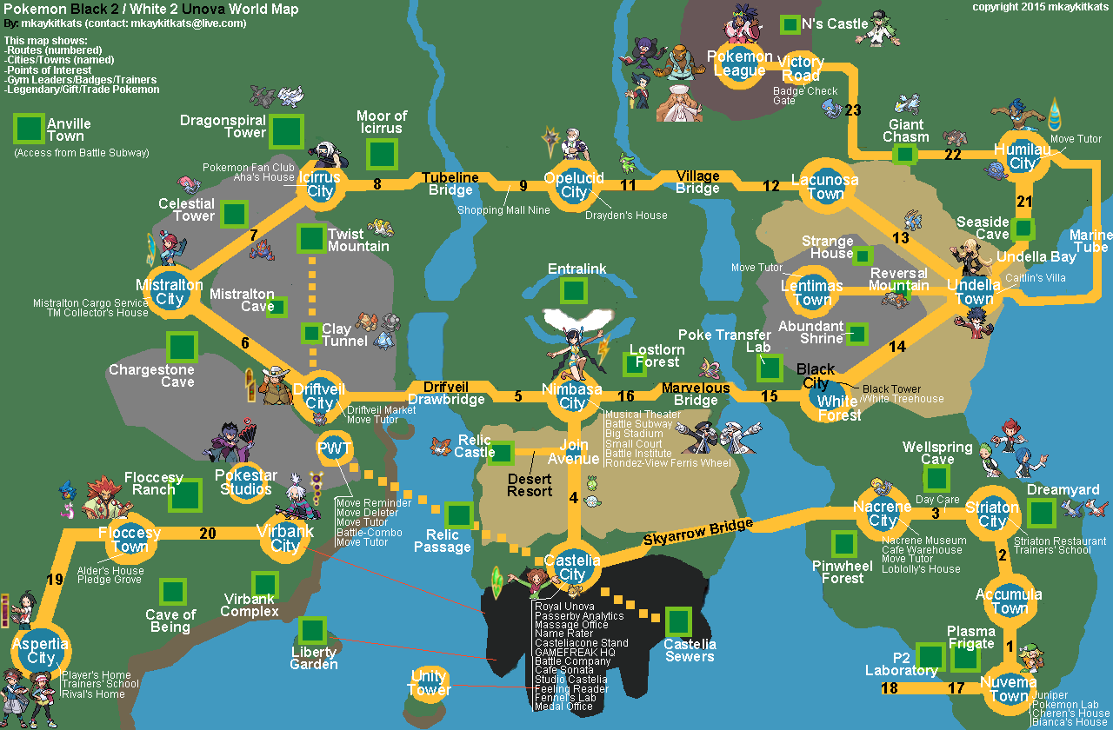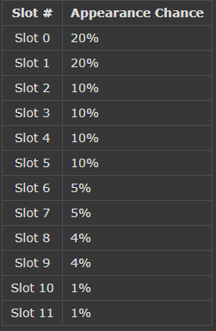Notes:

**Planning:**

This is created with a Nuzlocker’s perspective in mind. I’m aiming to increase diversity while not limiting Pokémon to unique events/time-gates like seasons. Keeping the levels consistent with the new level curve in mind is also something I’ll have in mind, and this plays into their evolutions too. Pokémon that evolve earlier feature more prominently in the early game to avoid situations where you either capture a Pokémon fully evolved and never see prior forms, OR capture Pokémon way past their evolution level and potentially miss out on specific moves.

While maximum diversity is possible with up to 12 different Pokémon per route, I personally think that reducing the overall level of *possible* Pokémon per route to increase the likelihood of different Pokémon each run is more desirable. While this almost certainly means there will be less overall Pokémon found in the game compared to a hack like Blaze Black 2, it DOES mean that *two people completing a Nuzlocke at the same time will have a less likely chance of receiving the same Pokémon on each route, or sequential runs*. As a brief explanation, I’m not interested in setting up the same situations as other mainline games/rom-hacks, where it’s almost *certain* you’ll either get a Magikarp with an old rod or a Zubat in caves. While those Pokémon aren’t bad, it’s not that interesting to receive the same Pokémon over and over again, especially on sequential runs. For that reason, I’ll be trying to ease away from standard traditions (Like early routes on featuring Patrat and Co.) to best reflect that.

I’m taking a lot of inspiration from Blaze Black 2 & Volt White 2 (BB/VW-2), as they set the standard for difficulty hacks in this generation, and are the most renowned. As such, a lot of comparisons will be drawn from them.

For collecting various types of Pokémon, Seasons are a great and unique feature to this generation; for nuzlockes they aren’t. Seasons lock specific Pokémon behind time-walls, and don’t *really* increase run diversity because most reruns are attempted immediately after previous runs, and as such seasons do not change between them. For that reason, I’ll be limiting the functionality of seasons. At most, I may vary the percentages of certain Pokémon appearing in seasons. *I’m trying to avoid situations where a Pokémon only appears on specific time frames, or situations where you’re likely to get the same Pokémon on sequential runs.*

While not necessarily a rule, I’d like to implement counters for each gym to be available. I will of course, be comparing this to the mainline games as well as BB/VW-2 in order to make sure there’s no overcompensation. Sometimes you only have access to a specific type in one area earlier in the game; in a nuzlockes setting this is disastrous if your only counter dies early in the run. To me, a counter is not only a Pokémon with super effective typing to the gym, but potentially one that resists the gym’s STAB attacks, or a Pokémon with neutral typing that learns super effective moves.

To touch briefly on fishing, while they often count as a bonus capture for cities where no grass is present (Almost all of them), I don’t really think that warrants them being null captures due to abundance of Magikarp with early game fishing rods. For starters, that’s an incredibly good early game Pokémon to receive, and in a hack where diversity is insisted upon it means water Pokémon (The largest type grouping) will need to be placed in grassy areas instead. There are a variety of water Pokémon that might not be considered very good, but are suitable when given as free water city captures, and I’ll be using those instead.

For formatting, I’ll generally break up each section in accordance with mainline events such as gyms, or where thematically appropriate so it’s easy to read. I’ll also put a small text box explaining my reasoning behind my Pokémon choices.

Audino in this game are giant sacks of exp that make grinding much easier and faster, however it’s a balancing act between putting in cool Pokémon to be found in rare shaking grass, or Audino for players to want to level up with. Not only is this a frustrating method to grind exp (because even when enjoying the benefits of Audino grinding, you can accidentally get rippling water phenomena instead of grass phenomena, or accidentally encounter a Pokémon walking to the shaking grass), but it also hurts the potential Pokémon diversity of routes, and hurts the viability of Audino itself (a sack of exp isn’t much use on your team). I’d much rather just put in trainers with high exp Pokémon like Happiny or Chansey that they player can rebattle for exp, because this streamlines the process and stops routes and Audino from compromising each other.

**Gym 1:**

Routes Included: Aspertia City Water, Route 19, Route 20, Floccesy Ranch

The first gym in B2/W2 is a normal type gym. In the mainline games, there are zero counters to normal types found on the preceding routes. In BB/VW2 there is a Mankey and potential Tyrogue available, however for the normal gym a type-counter is really for the most part just overkill. I think promoting diversity and setting up interesting dynamics for the following gyms is more important.

As mentioned in the planning section, I’d like early game water captures to focus on having weaker yet more diverse water captures, rather than just Magikarp. In this document I’m also focusing on a ‘First come first served’ mindset, where a Nuzlocker is only going to go for a capture the second it becomes available. With that in mind, I’m only listing the fishing rod captures for this section, because I don’t expect players to come back and surf later.

Shaking grass however, will also be listed here. While shaking grass is available after *only* the first gym and thus isn’t available as a capture until after, in my personal experience with hard difficulty hacks, we often do a ‘Gym Catch’ where you get a free capture for defeating the gym (To account for the high potential of lost Pokémon due to gym battles, as well as spicing things up and making defeating the gym feel like an achievement). For that reason, shaking grass will be included in this section.

**Aspertia City Water**: Lvl 3 - 7  
Krabby – 60%  
Lotad – 30%  
Wooper – 10%   
Rippling Water: Magikarp 65%, Feebas 35%

**Route 19:** Lvl 4 – 6   
Spinarak – 20%  
Sentret – 20%  
Wurmple – 20%  
Oddish – 20%  
Mankey – 10%  
Ledyba – 10 %  
  
Shaking Grass: Lvl 10 – 14   
Audino – 65%  
Aipom – 35%

Fishing: Lvl 3 - 7  
Krabby – 60%  
Lotad – 30%  
Magikarp – 5%  
Feebas – 5%  
Rippling Water: Magikarp 65%, Feebas 35%

**Route 20:** Lvl 5 – 7 *  
Weedle - 20% * Max level 6  
Caterpie - 20% * Max level 6  
Sewaddle - 20%  
Pidgey - 20%  
Spearow - 10%  
Starly – 10%  
  
Shaking Grass: Lvl 10 – 14  
Dunsparce - 65%   
Audino - 35%   
  
Dark Grass: - Lvl 10 - 15  
Beedrill - 20%  
Butterfree - 20%  
Sewaddle - 20%  
Pidgey - 20%  
Spearow - 10%  
Starly – 10%

Fishing: Lvl 3 - 7  
Krabby – 60%  
Lotad – 30%  
Magikarp – 5%  
Feebas – 5%  
Rippling Water: Magikarp 65%, Feebas 35%

**Floccesy Ranch:** Lvl 6 – 9   
Lillipup - 20%  
Snubbull - 20%  
Poochyena – 20%  
Houndour – 20%  
Growlithe – 10%  
Riolu – 10%  
  
Shaking Grass: Lvl 10 – 14   
Minccino – 65%  
Miltank - 35%  
  
Fishing: Lvl 3 - 7  
Krabby – 60%  
Lotad – 30%  
Wooper – 10%  
Rippling Water: Magikarp 65%, Feebas 35%

**Gym 2:**

Routes Included: Virbank City, Virbank Complex (Inside/Outside).

I don’t really think any straight psychic types would fit in the Virbank complex; that’s mainly going to be dominated by electric types. I’m attempting to avoid having different Pokémon inside and outside of the complex, as I’d like to avoid a situation where the player feels like they made a *mistake* not reading the documentation. Having ‘cooler’ or ‘stronger’ Pokémon found inside the Virbank Complex compared to the outside grass may result in that. While I originally planned to have the Pokémon the same in each area, I decided to instead make the areas reflect different types. The Outside reflects the Poison aspect of Virbank City, while the inside retains the electric type preference. This also allowed me to dump poison Pokémon that wouldn’t really have a place to be found elsewhere in Unova, (other than the Castelia Sewers, but I have other plans for that area anyway). These poison Pokémon will also provide resistances to the upcoming bug gym.

I can almost guarantee people will just go for the inside because they’re electric type or because they’re high levelled. While unfortunate, in this hack catching Pokémon at lower levels gives you better control over their moves, and I intend to make Pokémon more interesting in general to potentially break people’s perceptions of poison types (which are often just bad) regardless.

The shaking grass in this area marks the end of finding Audino in shaking grass. I chose to go for Pachirisu & Emolga for the shaking grass; they’re good at this point in the game, especially for the next gym which will most likely feature flying bug types weak to both Pokémon’s electric moves, as well as Emolga’s flying moves. Plus, they fit the electric theme.

Finally, for the city’s water I tried to emphasise the thematic presence of the poison gym, and as such two of the three common Pokémon are poison type. Chinchou was placed in here too, because it fits in thematically with the Virbank Complex. Feebas and Magikarp are also present in the rippling water for the final time, as I wanted to give another chance for players to grab one of them.

**Virbank City Water:** Lvl 10 - 17  
Qwilfish - 60%  
Chinchou – 30%  
Tentacool – 10%

Rippling Water:  
Feebas: 65%  
Magikarp: 35%  
  
**Virbank Complex (Outside):** Lvl 12 - 16  
Venipede – 20%   
Venonat – 20%  
Shinx – 20% *(Lvl 12 – 14)  
Electrike – 20%  
Grimer – 10%  
Magby – 10%  
  
Shaking Grass: Lvl 16 – 18  
Emolga – 65%   
Pachirisu – 35%

**Virbank Complex (Inside):** Lvl 15 - 18  
Joltik – 20%   
Magnemite – 20%  
Elekid – 20%   
Electrike – 20%  
Luxio – 10%  
Magby – 10%

Double Grass: Lvl 15 - 18  
Joltik – 20%   
Magnemite – 20%  
Elekid – 20%   
Electrike – 20%  
Luxio – 10%  
Magby – 10%

Shaking Grass: Lvl 16 – 19   
Emolga 65%   
Pachirisu - 35%

**Gym 3:**

From memory, this isn’t the biggest section regarding trainers and capture locations, however it certainly is one of the largest. It’s the bug gym, and while it’s most likely in a location where bugs won’t be *overwhelmingly* strong (as they would if this were the first, or even second gym), I don’t intend for this gym to be a pushover.

For captures, I’m going to move Sandile and other Pokémon that end up being weak to bug types further into the desert resort so that the Pokémon caught before the bug gym aren’t also useless when battling it. There’s nothing worse than preparing to challenge a gym, realising your Pokémon aren’t suited for it and then having captures that also don’t help. While I have kept some dark/psychic types around, there is a very large range of captures available, so I don’t think it’ll be a problem. The bug gym is definitely going to be difficult to account for that fact that people get 8 captures (assuming they’re doing 2 per location) prior to the gym though.

While I personally prefer to start with the base stage evolution of a Pokémon (it’s more interesting to have Pokémon in your party as they evolve through all their stages), this is definitely the last section I can do that with confidence for all Pokémon. I’ve already made plenty of concessions (And even lowered the wild-level below the standard wild-level cap for some), and it’s unrealistic to continue to do so as general levels continue higher and higher.

**Castelia Sewers:** Lvl 20 – 24   
Zubat – 20% *(Lvl 20 – 21)  
Stunky – 20%  
Woobat – 20%  
Gulpin – 20%  
Trubbish – 10%  
Koffing – 10%

**Relic Passage:** Lvl 21 – 25   
Cubone – 20%  
Sandshrew – 20% *(Lvl 21)   
Roggenrola – 20% (Lvl 21 – 24)  
Nosepass – 20%  
Geodude – 10% (Lvl 21 – 24)  
Gible – 10% *(Lvl 21 – 23)

Dust Clouds: Lvl 23 - 25  
Drilbur – 60%  
Bagon – 20%   
Baltoy – 20%

**Empty-Lot:** Lvl 22 – 26  
Skitty – 20%  
Meowth – 20%  
Glameow – 20%  
Hoppip – 20% *(22 – 23)  
Munchlax – 10%  
Vulpix – 10%

Double Grass: Lvl 22 – 26  
Buneary – 20%  
Farfetch’d – 20%  
Purrloin – 20% (Lvl 19)  
Machop – 20%  
Timburr – 10%*(22 – 24)  
Ralts – 10% *(Lvl 18 – 19)

Shaking Grass:  
Abra – 30% *(Lvl 12 – 15)  
Smoochum – 30%   
Eevee – 20%  
Togepi – 20% *(Lvl 10 – 12)  
  
**Route 4**: Lvl 24 – 28   
Gligar – 20%   
Hippopotas – 20%   
Numel – 20%   
Phanpy – 20% *(Lvl 21 – 24)  
Trapinch – 10%   
Larvitar – 10%

Fishing: Lvl 24 – 28  
Barboach – 60%  
Shellos – 30%  
Tympole – 10% *(Lvl 24)

Rippling Water: Lvl 24 – 28  
Stunfisk – 65%  
Corsola – 35%